AZURE DATA MANAGEMENT

AND

STATIC WEBSITE

* Create one storage account.

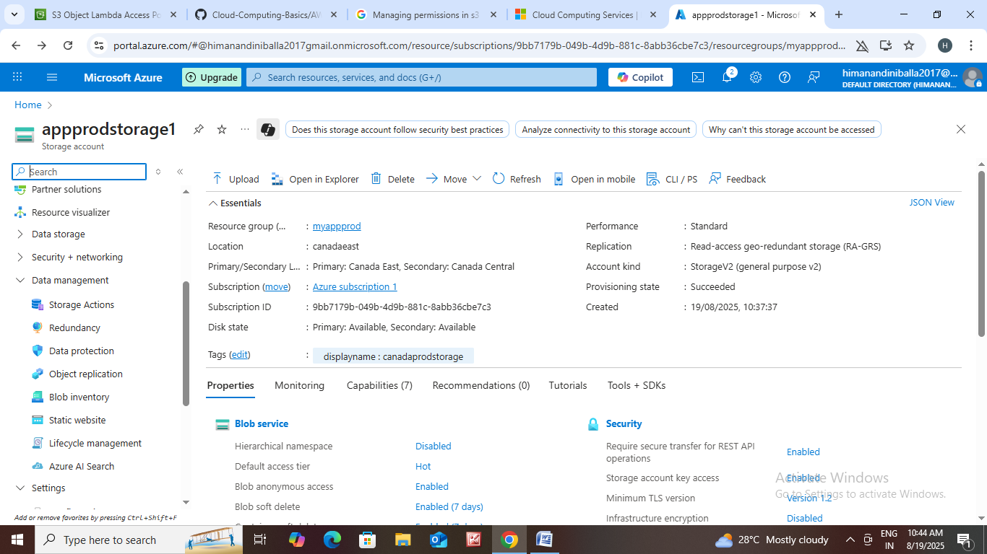

* Let us see data management options.

Storage actions : Storage tasks provide a framework for large-scale execution of common operations on objects for blobs and ADLS Gen2. Create a storage task activity to set up conditions for a task, and apply an activity to a storage task application.

* Click on storage actions.
* Then click on create task assignment.

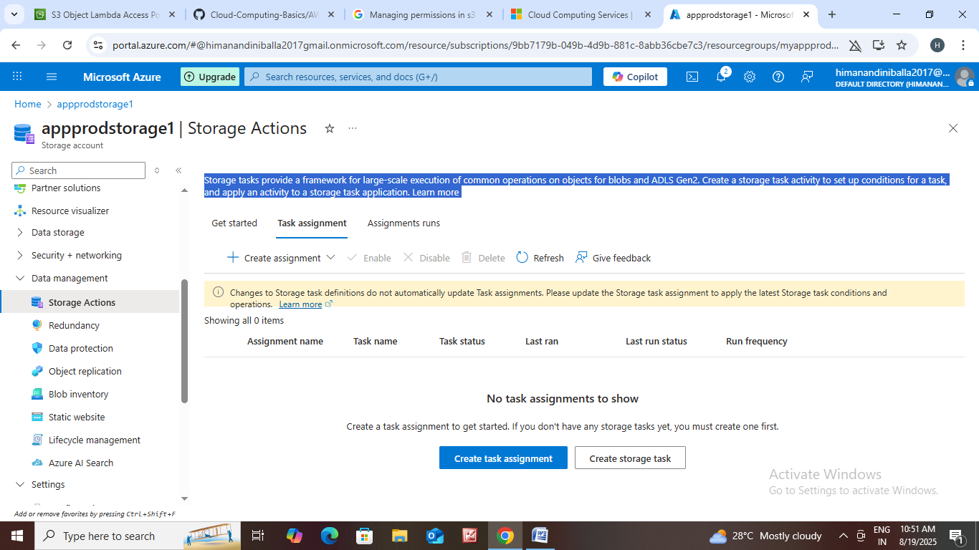

* In this storage actions we can add assignment.

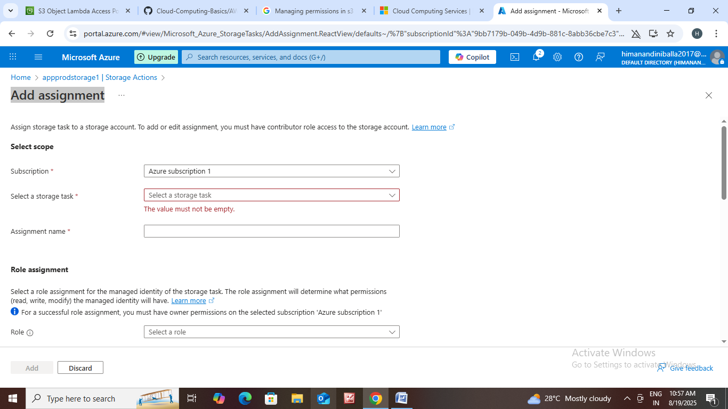

* Before adding an assignment you must create storage task.

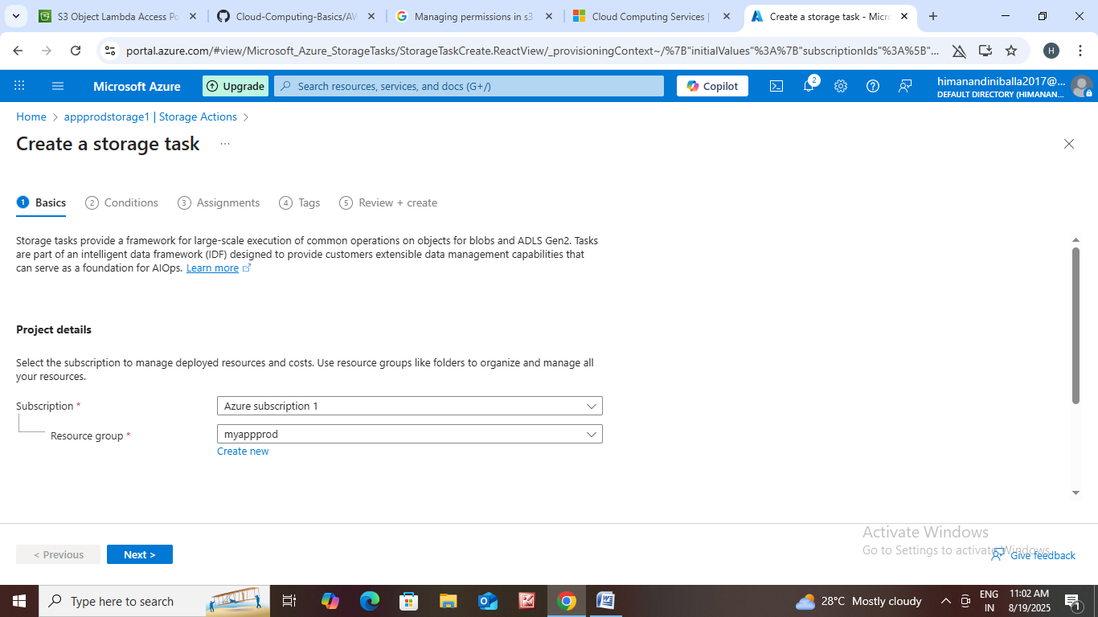

Redundancy : Azure Storage redundancy copies your data so that it is protected from transient hardware failures, network or power outages, and natural disasters. If an outage renders the primary endpoint unavailable, then you can initiate a failover to the secondary end point to rapidly restore write access to your data.

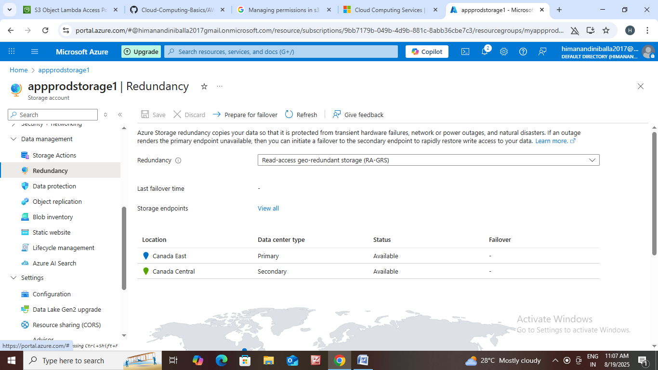

Data Protection : Data protection provides options for recovering your data when it is erroneously modified or deleted.

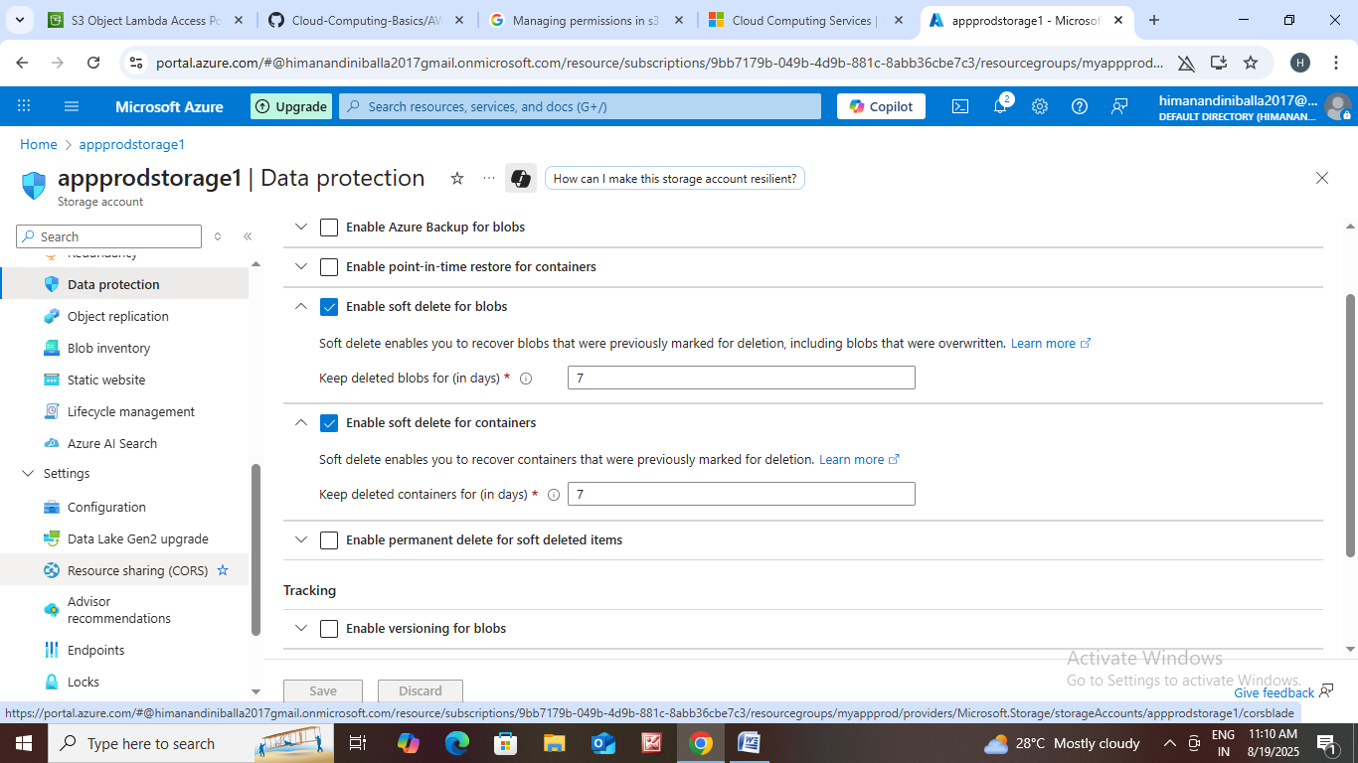

Object Replication : When object replication is enabled, blobs are copied asynchronously from a source storage account to a destination account.

Blob

File share

Queue

Table

Blob

File share

Queue

Table

Storage account1 Storage account 2

We can replicate data from one storage account to another storage account.

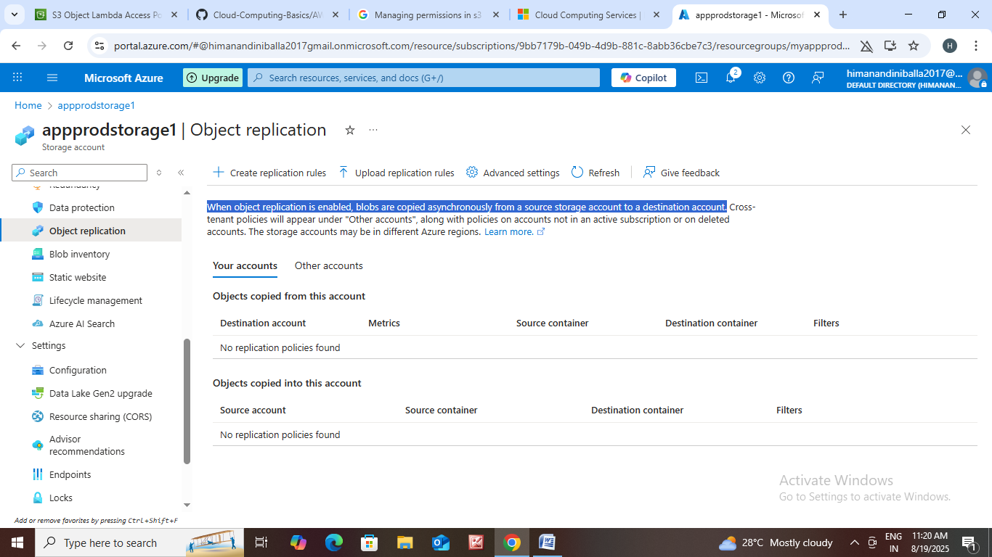

* Let us see how to replicate data from one storage account to another storage account
* Create one storage account 1 with resource group : app1 and storage account name : app1 storage.

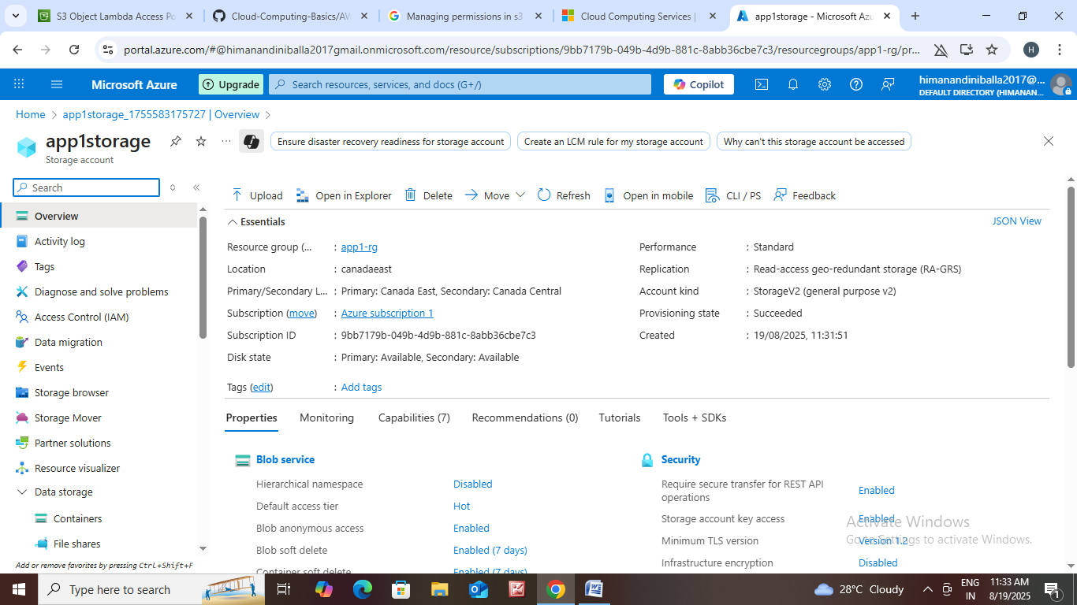

1. Create one container in this storage account.
2. Name that container

Ex: app1

1. In that container upload the file.

* Creat another Storage account 2 with same resource group : app1 and storage account name app 2 storage.

1. Create container in storage account 2.
2. Name that container

Ex: app2

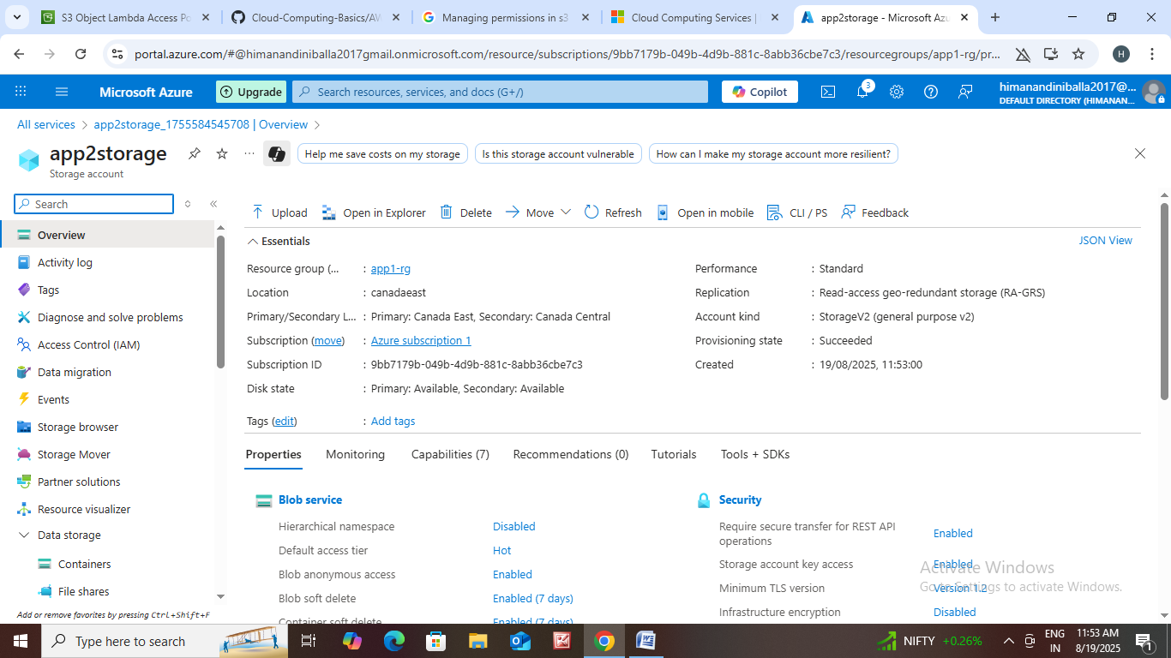

* Let us go to storage account1 click on object replication and create replication rules.

1. Destination storage account : app2 storage
2. Source container : app
3. Destination container :app2
4. Enable Replication monitoring.
5. Then click on create.

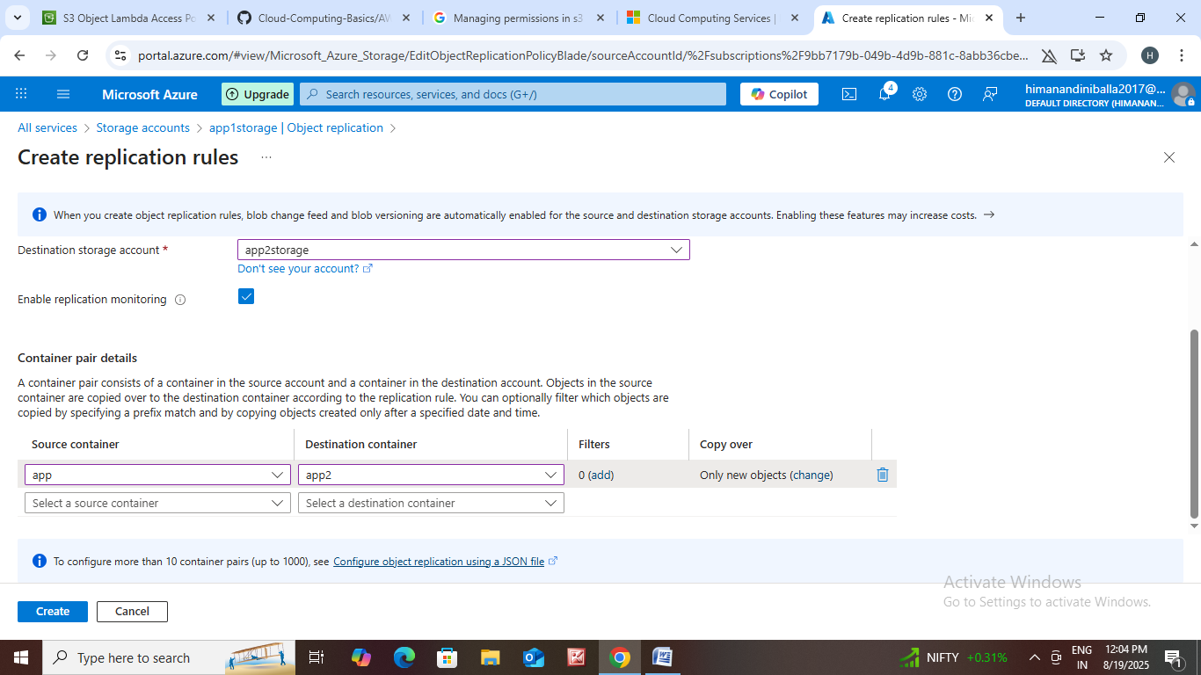

* Let us create blob inventory on storage account1.

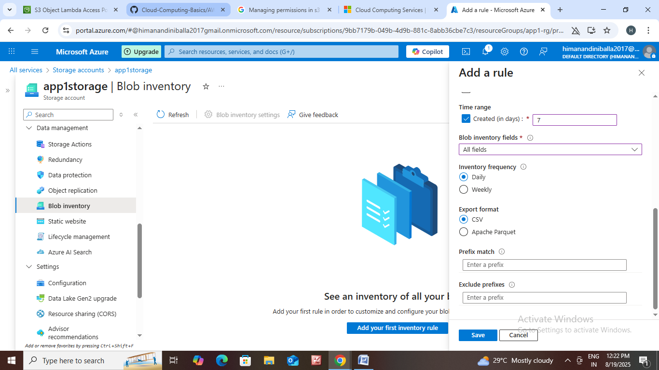

* Add a rule for that storage account.
* Save the rule.

Static Website : This feature allows you to directly serve static content like HTML, CSS, JavaScript, and image files from a container in a general-purpose V2 or Block Blob Storage account.

* How it works: When you enable static website hosting, a special container named $web is created in your storage account. You then upload your website files into this container.

1. Click on static website then the page is open.
2. After that Enable static website.

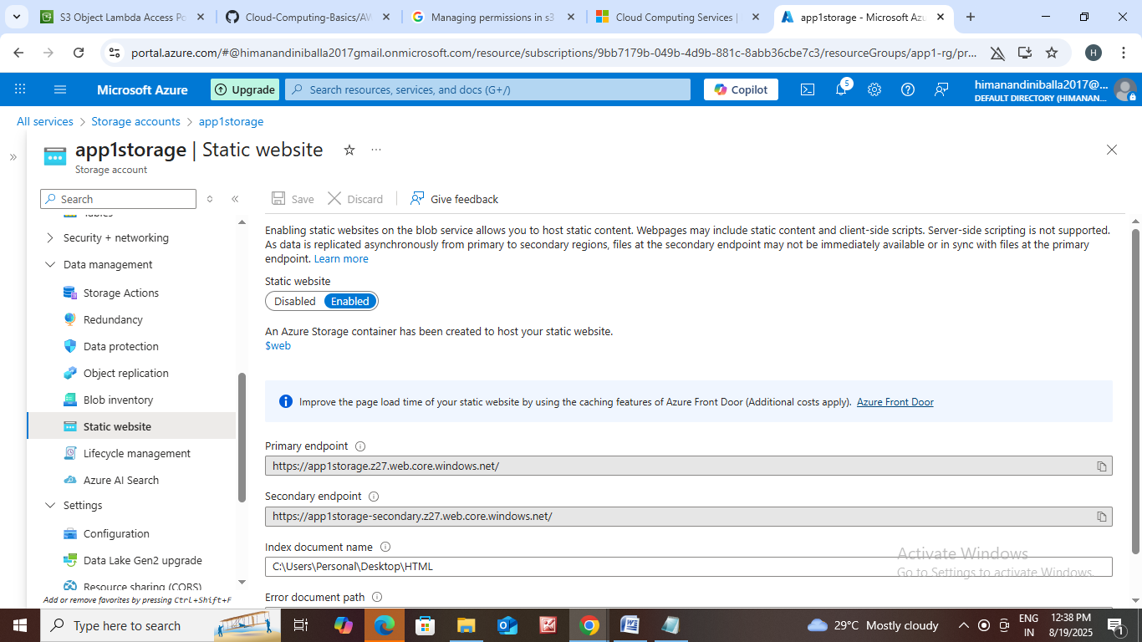

1. We can add any index document name from your files.
2. Next click on container .
3. In container we can see $web then click that one we can upload files on it.

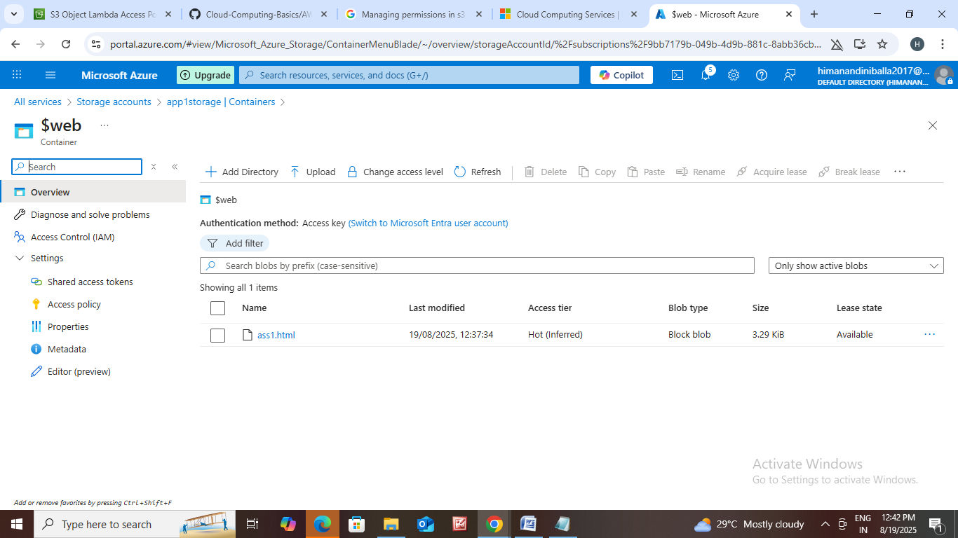

Lifecycle Management : Lifecycle management offers a rich, rule-based policy for general purpose v2 and blob storage accounts. Use the policy to transition your data to the appropriate access tiers or expire at the end of the data's lifecycle. A new or updated rule can take up to 24 hours to go into effect.

1. Click on lifecycle management.
2. Add a rule.
3. Rule name :rule 101
4. We can add some rules on it based on your data.
5. How many days you want to store that data you can mention the number.
6. Ex: you want to store 2 days. After 2 days the data will be deleted otherwise you can move that data to another place.

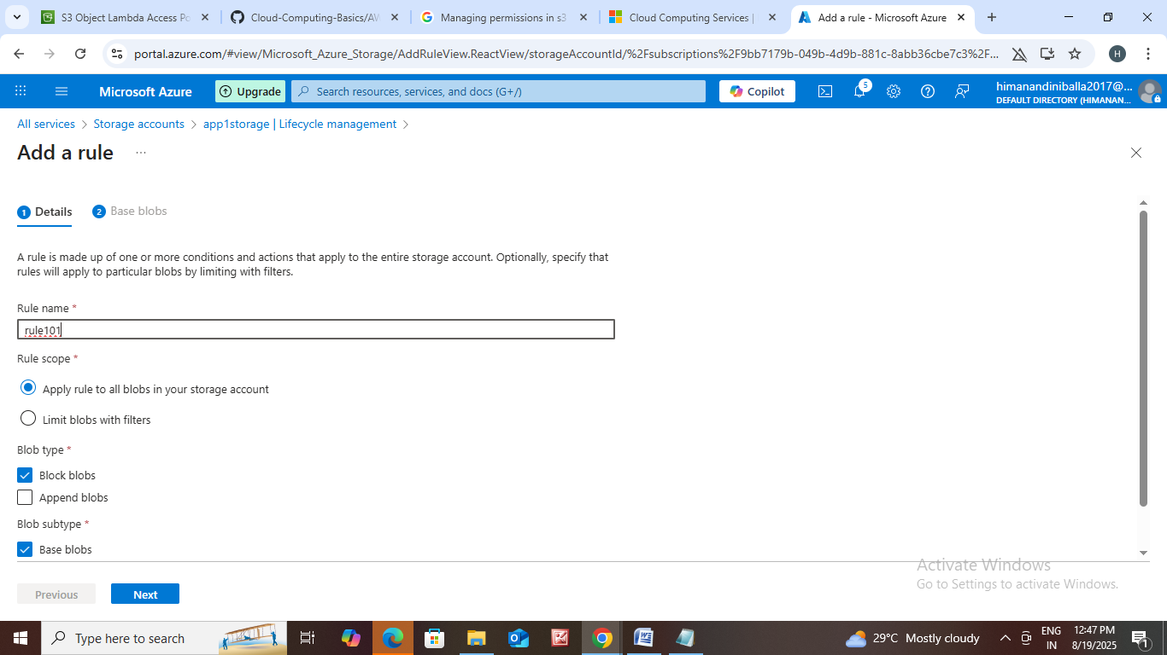

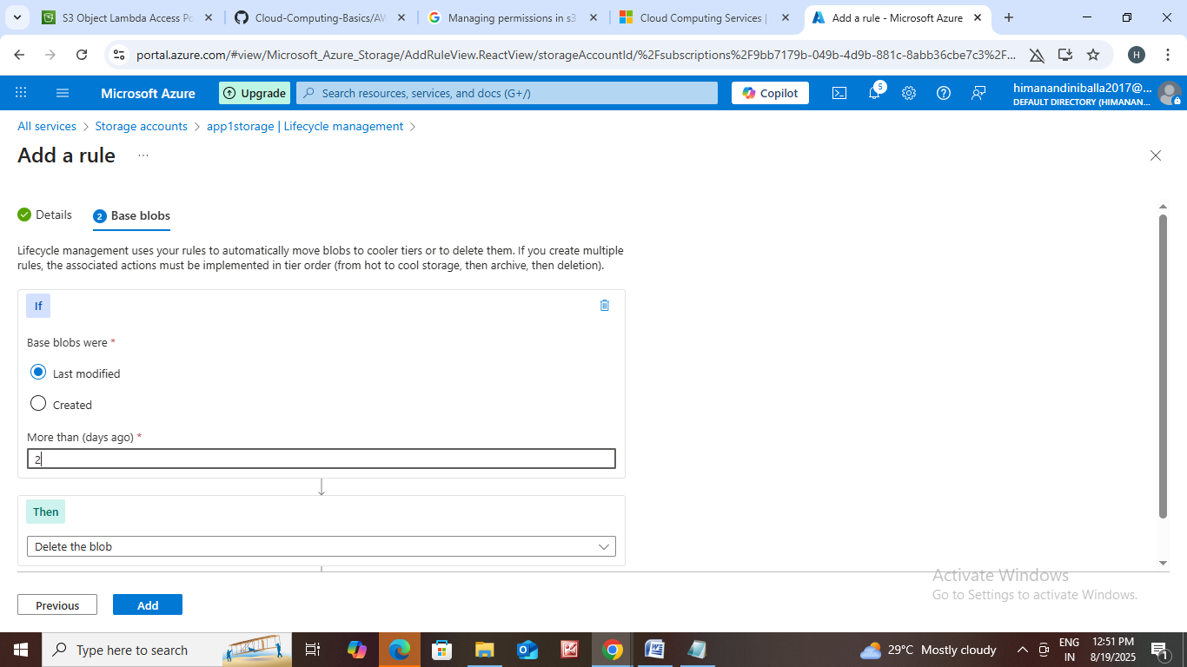

1. Add that rule.

Azure AI Search : Azure AI Search, formerly known as Azure Cognitive Search, is an enterprise-grade information retrieval system in Azure that powers both traditional and modern AI search applications.

